**Climate Research & Impact Visualisation**

John Mutua, Lila Sakata, Zachary Li

The Edinburgh Earth Initiative

July 2022

**Contents**

Introduction 3

Objectives 5

Methods 6

Findings 7

Sources of funding 7

Application success rate 7

Research funding distribution among colleges and schools 8

Distribution of active projects 9

Research impact around the world 10

Research outcomes 10

Major domains of research 11

Limitations 12

Database 12

Methodology 13

Recommendations 14

Conclusion 14

References 16

Appendix A: Boolean logic used to search the UKRI and ERO databases for projects relevant to climate, sustainability, and the environment. 17

Appendix B: Categorization of keywords in overarching themes 18

# Introduction

In recent years, research in climate, environment and sustainability has grown rapidly within the University of Edinburgh. Research outputs are often available as scientific articles, technical reports, or policy briefs. Research within the university is sponsored by a range of funders, with UKRI being the largest contributor to award funding (Figure 1). These institutions have created enormous public-facing databases to keep track of research funding but lack sufficient information linking research projects to impacts. Therefore, it is difficult to gain an accurate representation of the extent of climate-related research, especially on a global scale, as the number of projects rises, and research outputs are continuously released. Recent research has documented the misallocation of climate research funding (Overland & Sovacool, 2020).

Figure 1: Pie chart illustrating the total amount of funding awarded total by sponsor type from 2016 to date

The Edinburgh Research Office (ERO) provides research analytics on crucial components of the research being conducted across the institution, such as sources of funds and award totals for projects. The Edinburgh Earth Initiative (EEI) sought to establish a deeper understanding of the University of Edinburgh's current research in climate, environment, and sustainability. The findings are to be circulated within other groups across the University to inform the extent of climate research. The initiative aimed to uncover high-impact case studies often underrepresented in the University’s corporate narrative on climate. Despite having a comprehensive database for research conducted within the University of Edinburgh, the database from ERO has limitations, e.g., ERO does not track impacts and outcomes. However, this information is available from the UK Research and Innovation (UKRI) Gateway to Research portal <https://gtr.ukri.org>, although it is limited to what is reported by Principal Investigators (PIs). We intend to provide insight into climate-funded research from a systematic perspective. In this study, we take one step toward filling that gap. We are unique in compiling a set of keywords and an algorithm that makes data mining from research portals more robust.

# Objectives

This study analyses the data held by key partners including the EEI, ERO and UKRI to establish a more comprehensive understanding of the University of Edinburgh's research in climate, environment, and sustainability. The questions we addressed included:

1. Which are the primary funding bodies?
2. What is the application success rate?
3. How is research funding distributed among colleges/schools?
4. What is the distribution of active projects?
5. How is the research distributed around the world?
6. What are the various research outcomes from projects?
7. What are the major domains of research?

We sought to answer these questions based on the research that has been conducted by university faculty staff on climate, environment, and sustainability worldwide, from 2017 to the present. We used the UKRI and ERO databases to extract this information and used R programming to analyse and visualize the data. Our research is intended for the Edinburgh Research Office, the EEI team, and other stakeholders interested in climate-related research at the University of Edinburgh.

# Methods

To catalogue the large volumes of project data stored in the UKRI and ERO research portals, we gathered a collection of keywords to effectively extract all climate-related projects. The [UKRI Gateway to Research](https://gtr.ukri.org/) search functionality allows the combination of multiple keywords with Boolean operators to search by project titles, abstracts, references and ORCID. On the contrary, ERO can only search by one keyword at a time. We developed a R script to search the UKRI portal through the GTR-2 API, and manually downloaded ERO data to implement the search outside the ERO portal. This allowed extraction of information from these portals with speed and accuracy. The Boolean logic used is available in Appendix A. The workflow is available in the [EEI GitHub account](https://github.com/edinburgh-earth-initiative).

We determined the relevance of each keyword by manually analysing for the pertinence of the results of a single keyword search. We refined the keyword list depending on any irrelevant projects being filtered in, and relevant projects filtered out for each search. Similarly, we cross-referenced the accuracy of keyword search results by repeating the same process on a more extensive scientific literature database (Web of Science). Keywords were identified as satisfactory if >90% of the resulting projects were relevant to the themes of climate, sustainability, or the environment. In total, we extracted 1289 projects (Applications and Awards) from the ERO database and 834 projects (Awards) from the UKRI database. Data that contained typos, outdated Institute/School names and inaccuracies were corrected to facilitate the categorization of projects within sub-units of the University.

We assigned keywords to climate-related categories using two different frameworks to identify trends in various fields of research from the project databases (see Appendix B: Keyword categorization). The first framework follows the Intergovernmental Panel on Climate Change (IPCC)’s structure into three Working Groups: Physical Science Basis (WGI); Impacts, Adaptation and Vulnerability (WGII); and Mitigation of Climate Change (WGIII). The second framework contains four categories that are both thematic and geographic: Atmosphere, Land, Ocean, and Human Just Transitions. We expanded the scope of the IPCC framework to include all sustainability and environmental issues alongside climate change. Keywords can lie within a single category or pertain to two or three categories at once.

# Findings

## Sources of funding

Project funding comes from a variety of sources. In the year 2021, 40 percent of climate related projects were funded by the UK research council. Other major funding sources include the EU Government, UK charities, the UK Government, and other institutions from within the UK and overseas (Figure 2).

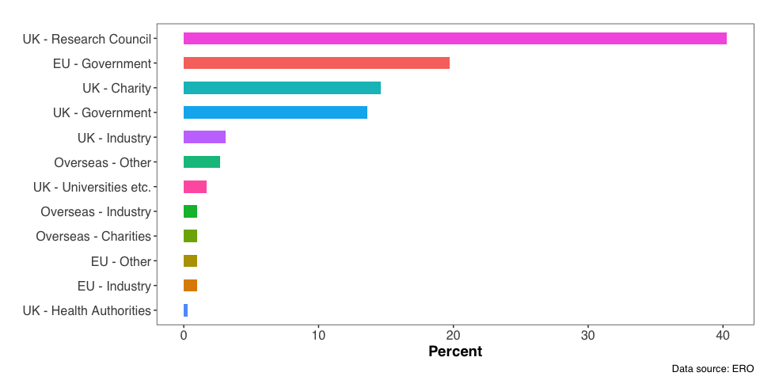

Figure : Sources of funding for the year 2021

## Application success rate

The application success rate for climate-related research has been on the rise since 2015 across all colleges at the University of Edinburgh (Figure 3). Success rates saw a decline from 2018-2020, and may be attributed to the global pandemic (Oxford Analytica, 2020). The coronavirus disruption has had far-reaching consequences for scientific research, as the pandemic reduced the amount of funding from direct donations and government and charitable grants (Stoye, 2020). Success rate is now increasing at a rate that considerably supersedes the ERO average success rate (28.26%) for projects of all disciplines.

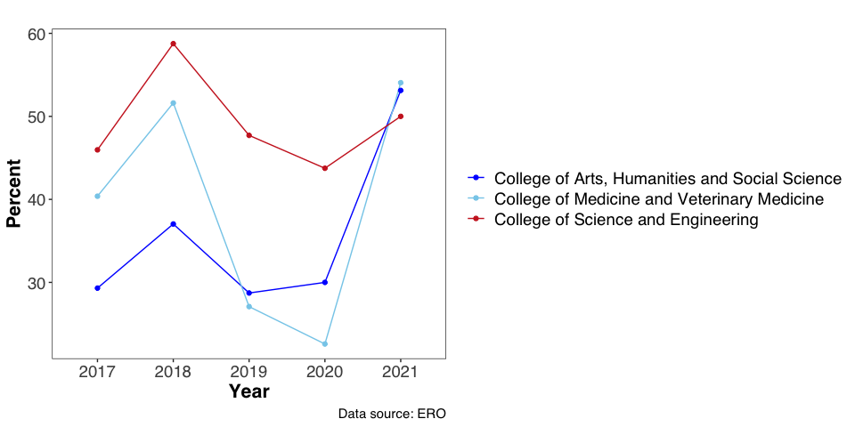

Figure : Application success rate since 2017

## Research funding distribution among colleges and schools

In 2021, the College of Science and Engineering received the most amount of research funding for climate-related projects out of all the colleges at the University of Edinburgh (Figure 4). This is to be expected, as research within the Schools of Geosciences, Biological Sciences and Engineering within the College of Science and Engineering are inherently relevant to environmental and sustainability themes.

On the contrary, the College of Arts, Humanities and Social Sciences received the least amount of funding related to climate and sustainability, likely due to a lack of an inherent academic linkage with these themes. Despite this, the College’s unique perspective on ethics, justice, and responsibility is a crucial component of the University’s initiative toward climate change. Increased funding in humanities projects would encourage a more interdisciplinary approach toward environmental research, not only influencing policymaking but also framing climate change in a more effective manner for a broader audience (Robin, 2018).

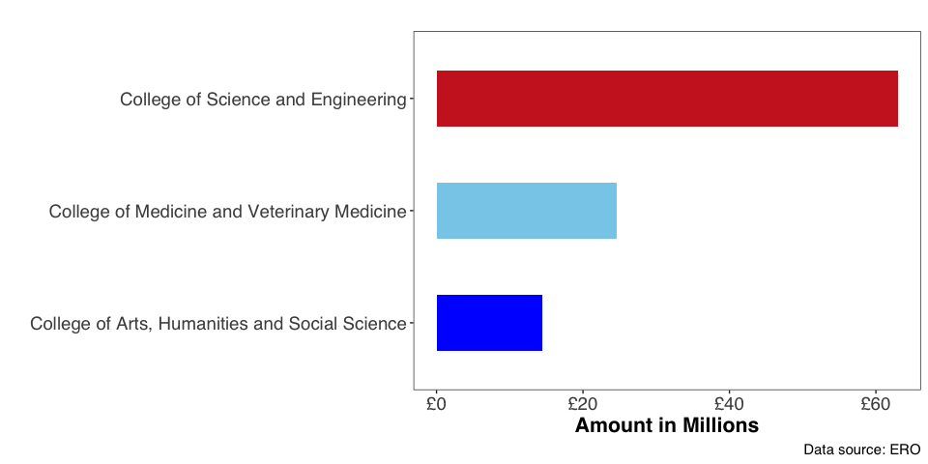

Figure : Funding distribution for the year 2021

## Distribution of active projects

The College of Science and Engineering has the most active projects pertaining to climate, environment, and sustainability (Figure 5). This trend is to be expected because of the underlying interconnectedness between themes within the College of Science and Engineering and climate-related research.

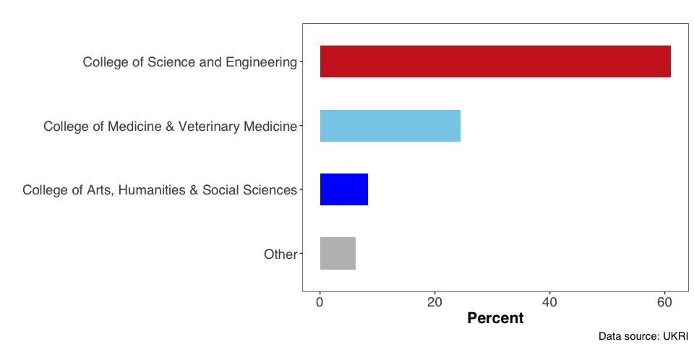

Figure : Distribution of active projects as of July 2022

## Research impact around the world

Every college conduct research that varies on a geographical scale. However, most of the three colleges' climate research is focused on a global scale (Figure 6). The University’s expansive international network is highlighted in the geographical reach of climate research. Research opportunities and international engagement at the University is facilitated by its extensive network of global relationships (e.g., by Edinburgh Global).

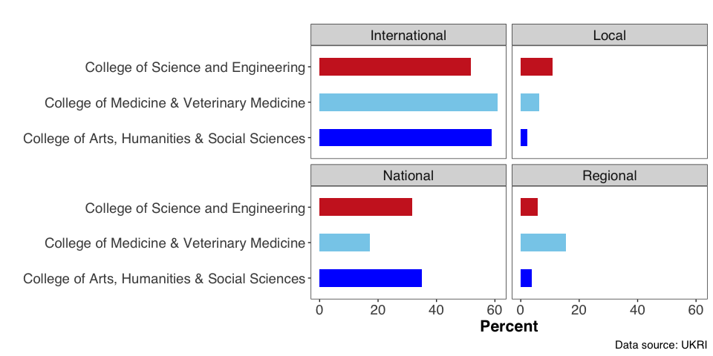

Figure : Geographic scale of research

## Research outcomes

There have been various research outcomes from climate related projects ranging from engagement activities to intellectual property. All the three colleges have various levels of engagement activities and collaborations. The colleges of arts, humanities and social sciences and science and engineering leads in policy influence (Figure 7).

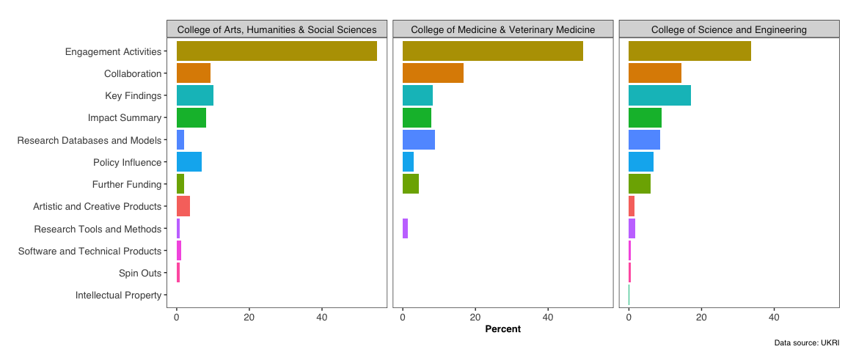

Figure : Research outcomes from climate related projects

## Major domains of research

Climate-related research at the University spans all three IPCC themes. However, most research advances are efforts to mitigate climate change, with about 20% of projects focusing on the nexus of physical science, adaptation, and mitigation (Figure 8).

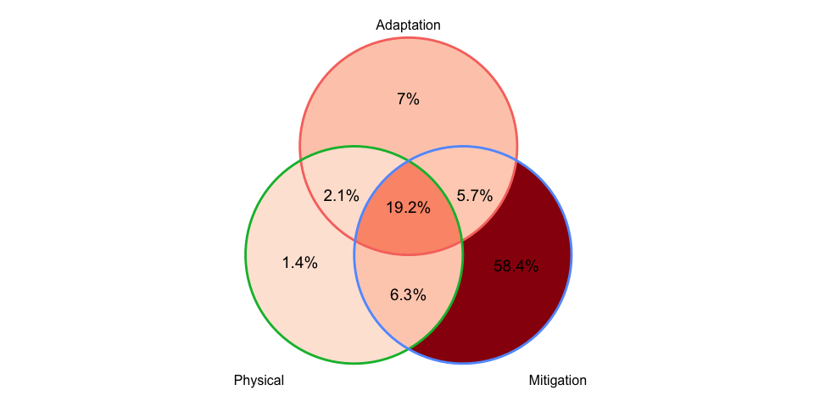

Figure : Representation of IPCC themes in the University’s climate related projects

# Limitations

### Database

We investigated the ERO and UKRI databases separately. One of the main issues we identified was that there were no common unique identifiers for UKRI funded project between both databases. Both the UKRI and ERO databases assign a unique identification/reference code to every project but differ in their structure between the two databases. This makes it difficult to establish associations between UKRI and ERO projects, as the databases are essentially not comparable.

Moreover, there were spelling differences in key fields pertaining to the same project between UKRI and ERO. For example, the name of the principal investigator was spelled differently despite being the same project. In addition, we identified other inconsistencies between the two databases. When compiling a list of all the projects awarded funding at the University of Edinburgh from UKRI and ERO, some projects only appeared on one of the databases. This implies that the ERO is potentially not tracking all the projects funded by UKRI.

The ERO database has several limitations for sequencing project data.

1. The search engine can only search for one keyword at a time, lacking the capability to gather large volumes of data promptly. Because of this, users intending to extract data across several topics would be obligated to use an external tool such as R or Python to visualize.
2. ERO engine allows searching by project titles containing a specified keyword, rather than searching through other crucial identification components such as project abstract, project description, or planned impact.
3. Project titles in the database are occasionally misspelled and hence excluded from our keyword search. This implies that the dataset of climate-related projects we extracted from ERO using a keyword search is likely an underrepresentation of the true extent of climate research conducted across the university.
4. Inconsistent terminologies used in domains of research and the structure of these data portals. This creates a challenge for data mining, requiring further time to apply corrections for further analysis.

The UKRI database has several limitations for sequencing project data.

1. Project descriptions vary widely in the level of detail, with some projects having extensive paragraphs structured under “abstract” and “planned impact,” while others are summarized by a single sentence. The shorter the project description, the less likely it is for keywords to ping a project relating to the overarching sustainability, climate, and environment topics.
2. Keyword search is not entirely precise, as projects with similar keywords with slightly different spellings may appear in the search results (i.e., searching the keyword “ecological will return projects containing “ecology”).
3. Engine does not provide the user with an extensive geographical filter on an international scale on the front-end of the interface. Projects awarded outside of the UK are classified as “Outside UK,” which makes it difficult to accurately map the geographical reach of funding and less frequently targeted areas.
4. Lack of cohesion in the process of tracking geographical reach associated with project outcomes, as many outcomes lack information regarding their geographical scope.
5. Geographical outcomes that are available are likely inaccurate. This is evident in map we produced based on geographical reach linked to project outcomes, as we observed significantly less projects in the UK than expected.

### Methodology

Our keyword collection and sequencing process has several limitations.

1. Keywords used do not extract the entire set of projects associated with climate, environment, or sustainability. In essence, there are other keywords we have not brainstormed that would pull further climate-related projects from the databases. This indicates that our data mining methodology has not captured the full-extent of climate-related projects.
2. Keywords in have inherent inaccuracies in the projects extracted from the databases. Because we determined keywords as satisfactory when pulling results with >90% accuracy, some of the projects pulled from the database were not related to climate, sustainability, or environment. Nevertheless, these were still included in the dataset of climate-related projects. This implies that the current dataset of projects is an overestimate of the climate-related projects using the keyword set in Appendix A.
3. Sorting of keywords into the domains of research was conducted manually by the EEI team. As a result, the keywords were sorted into categories based on the subjectivity of the EEI team, implying that projects attributed to a certain category may belong in other domains of research or categorized incorrectly.

# Recommendations

We recommend that ERO should include these extra components in the proposal submission form: Where is the project occurring (study-site)? We suggest the study location be structured in three checkboxes: (i) Global, (ii) Regional, and (iii) National. If applicants were to select the “Regional” or “National” checkboxes, they would be able to further identify a more specific region or nation their research would be located in. By adding this component, the ERO will be able to visualize where projects are occurring on a map. This allows funding bodies to identify regions where research is lacking and less prominent, and potential areas in which more funds need to be allocated.

We also recommend that the ERO add the capability to search for multiple keywords at once, making it more convenient to extract large volumes of data at once. An example of this workflow is available in the R workflow developed which can be embedded into the Power BI search functionality in ERO engine and allow for search through abstracts. In addition, developing the ability to search through project abstracts would pull more climate-related projects and ultimately improve the search accuracy.

We recommend that the UKRI GtR include complete project abstracts, not shortened ones. A multitude of projects in database contain shortened project abstracts, often ranging from 1-3 sentences long. This makes it difficult for our keyword search to capture the full extent of climate-related research on the database, as relevant projects are left out of the search process due to the scarcity of project information.

The workflow we developed could be improved to allow more text mining in the UKRI and ERO databases. For example, functions could be developed to include mining collaboration, publications, and outcome data from UKRI. The functions could be packaged into a R package and deployed as an R shiny application to enable user friendly use within EEI.

# Conclusion

We believe that future scientific advances will emerge from not only major scientific innovation but also through the analysis of existing data and through looking out for major gaps in research. Our findings highlight the trends in climate-related research across the University of Edinburgh from two reputable databases, illustrating a more comprehensive narrative on the institution’s climate initiative. Our main takeaways are:

1. Climate-related research has a much higher application success rate than the ERO success rate for applications across all fields.
2. The College of Science and Engineering receives the greatest proportion of climate-research funding and has the most active climate-related projects out of all the colleges at the University of Edinburgh.
3. Most of the climate-related research at the University of Edinburgh is focused on climate change mitigation.

Our work provides a baseline for climate-related research funding and serves as a blueprint for future work in this field.

# References

Overland, I., & Sovacool, B. K. (2020). The misallocation of climate research funding. *Energy Research & Social Science*, *62*, 101349. https://doi.org/10.1016/j.erss.2019.101349

Oxford Analytica. (2020). Pandemic response threatens climate funding shortfall. *Expert Briefings*. https://doi.org/10.1108/OXAN-GA256969

Robin, L. (2018). Environmental humanities and climate change: Understanding humans geologically and other life forms ethically. *WIREs Climate Change*, *9*(1), e499. https://doi.org/10.1002/wcc.499

Stoye, E. (2020). How research funders are tackling coronavirus disruption. *Nature*. https://doi.org/10.1038/d41586-020-01120-2

# Appendix A: Boolean logic used to search the UKRI and ERO databases for projects relevant to climate, sustainability, and the environment.

"climate change" OR "climate crisis" OR "global warming" OR "carbon sink" OR biodiversity OR conservation OR "global change" OR "ocean acidification" OR microplastic* OR pollution OR "greenhouse gas" OR "greenhouse gases" OR "atmospheric carbon dioxide" OR "stratospheric ozone" OR "ozone depletion" OR coral* OR reef* OR "extreme weather" OR "sea level" OR environmental OR "water quality" OR "air quality" OR anthropogenic OR "blue carbon" OR deforestation OR "circular economy" OR "energy transition" OR "fossil fuel" OR "fossil fuels" OR renewable OR decarbonisation OR "energy storage" OR "food security" OR "nutrition security" OR "nature based" OR "paris agreement" OR "eco" OR "waste" OR "recycling" OR sustainable OR sustainability OR anthropocene OR "climate justice" OR "climate action" OR "natural hazard" OR "natural hazards" OR permafrost OR sequestration OR "remote sensing" OR peatland* OR "species richness" OR groundwater OR "carbon footprint" OR ipcc OR unfccc OR methane OR "ecosystem services" OR overfishing OR aquaculture OR "clean energy" OR biogas OR afforestation OR "storm surge" OR "endangered species" OR "carbon pump" OR "carbon cycle" OR oceanography OR "trophic cascade" OR "primary productivity" OR "growing season" OR "crop production" OR "carbon balance" OR "urban heat island" OR "green space" OR eutrophication OR biochar OR "radiation balance" OR upcycling OR "climate variability" OR "carbon source" OR biofuel OR "environmental justice" OR "wave energy" OR retrofit OR "carbon capture" OR wildlife OR biodegradable OR "climate warming" OR "marine energy" OR "crop yield" OR pollination OR "zero emission" OR floodplain OR "nutrient deposit" OR hydroponic OR "flood forecast" OR nox OR "algal bloom" OR lca OR "ice flow"

# Appendix B: Categorization of keywords in overarching themes

